Mini max tic-tac-toe
You will:
- Use, create own and adjust existing data structures.
- Estimate Big(O) of your algorithm.

Assignment
You will implement a well-known mini-max algorithm or any variation on it. The algorithm is presented in the slides- feel free to also google for additional information that can help you.
The mini-max will be solving either a tic-tac-toe game or any other simple game of your choice.

Nonfunctional requirements
- UI is unimportant
- Unit tests are required! Each step of your algorithm should be validated.
- Estimate memory and calculations complexity in Big (O)

Functionality

Step 1: Initialize game board
Create a data structure to hold the state of the game. Start the game by a random board setting. From now on one player plays min and other max depending on who has the turn. So mini-max will guide the steps taken.

Step 2: Calculate next step
Create a function that drives the game, feeds the current board state to an algorithm and then updates it with best move.

Step 3: Max method and min method
Depending on turn a method that uses either max or min strategy. These can be best implemented in separate functions.

Contest!
Can your algorithm beat other class-mates algorithms?

Complexity Analysis
My Mini-Max search algorithm with alpha beta pruning technique simulate a tic tac toe game move, and I estimated the time complexity value to be approximately O(n^2(n-1)!), where n is the edge length of the board (so board with edge 3 has 9 cells) .
 | Game Board Size 3X3 | Game Board Size 4X4 | Game Board Size 5X5
Time execution (ms) | 32ms | 20867ms | 731211ms
The memory space complexity is O(b^2), where b is the board edge length. Since the algorithm use DFS approach to navigate the tree and stops until a game is finished instead of checking depth, the memory used is equal to all squared board edge length.
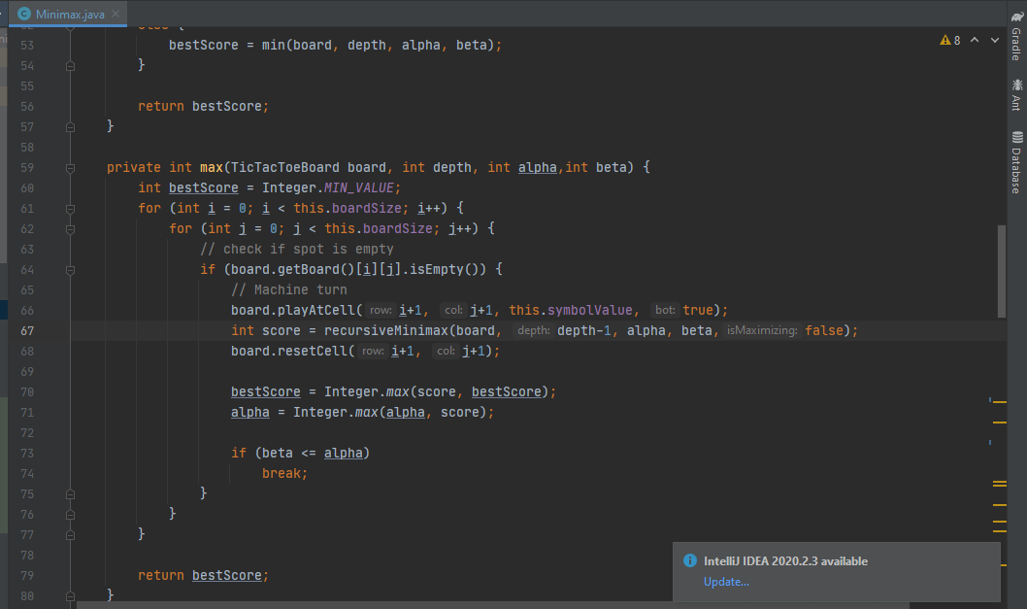 Screenshot took from source code.
Although this recursive function has double nested for loop, they count as O(9) because a tic tac toe board game can only have 9 cells to play.

